**Create JDBC Connection**

1. Download JDBC driver 5.1.41 (latest ver) from <https://dev.mysql.com/downloads/connector/j/5.1.html>  
   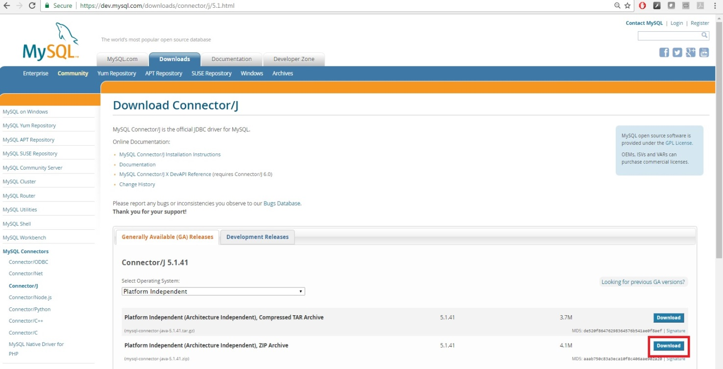

I downloaded the zip file.

1. Unzip the zip file
2. We need to add the jar file to our Java project. I use eclipse, so here is what I did.
3. Add jar file to library:
4. Right click JRE System Library->Import

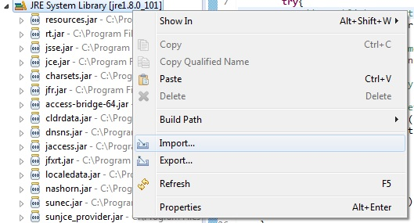

ii. Choose File System

1. Find where you unzipped the JDBC driver and import it into your Java project folder.

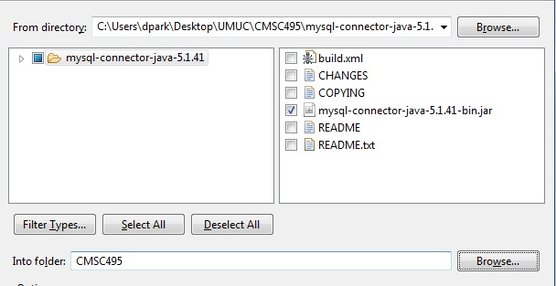

1. Add the jar file to build path
2. Right click project folder -> Properties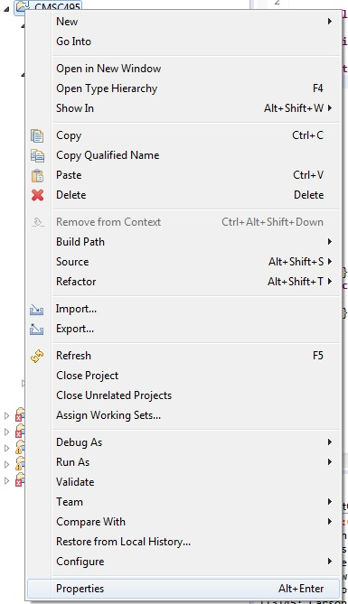
3. Go to Java Build Path -> Add JARs and you should find the JDBC Driver jar file in your project folder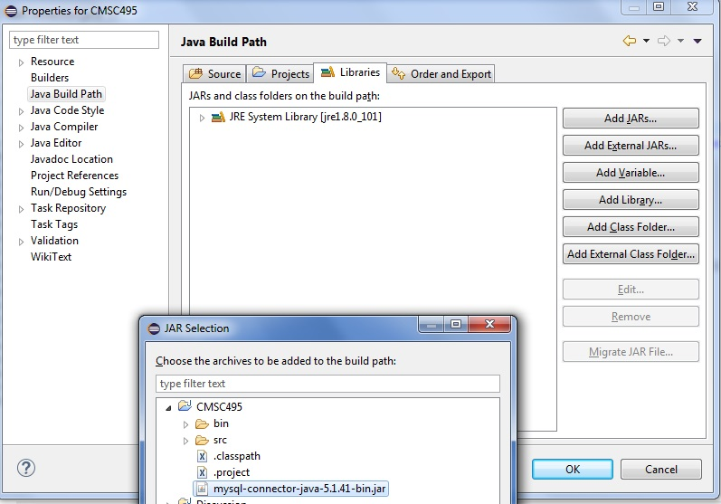
4. Test connection in Java. I have uploaded **TestConnection.java** file to GitHub. Run the program, it should retrieve a basic result set.